Environmental Literacy Carbon Assessment:
--- Middle School Level, Form C ---
Science is easier to understand if you can make connections between what you know now and the new ideas that you are studying. This is a test that will help us to understand what you know now. Please answer these questions as carefully and completely as you can. If you are not sure of the answer, please write about any thoughts that you have. If you can help us to understand how you think about these questions, then we can do a better job of explaining science in ways that make sense to you.

Please put your initials (not your full name) in the boxes
Date ________________ | First | Middle | Last
Class ____________________________ Teacher _______________________

1. Your body needs heat to keep its normal temperature. Where does the heat mainly come from? Please choose ONE answer that you think is best.

- The heat mainly comes from sunlight.
- The heat mainly comes from the clothes you are wearing.
- The heat mainly comes from the foods you eat.
- When people exercise, their bodies create heat.

Please explain why you think that the answer you chose is better than the others. (If you think some of the other answers are also partially right, please explain that, too.)

2. A scientist made three groups A, B, and C, like the following:

A. Sugar, meat, bread
B. Water, limestone, sand
C. Coal, gasoline, wood

a) What makes each group go together?
Group A:

Group B:

Group C:

b) Why would water go with limestone and sand rather than sugar and meat?

c) Does it seem to you that groups A and C have anything in common? Yes / No

Please explain your answer. If no, explain why you think these groups are different. If yes, explain what the groups have in common.

3. When you are riding in a car, the car burns gasoline to make it run. Eventually the gasoline tank becomes empty.

a) What happens to the matter the gasoline is made of?
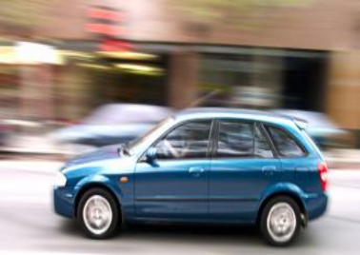

b) When the gasoline tank becomes empty and the car stops, what happens to the energy of gasoline? Where does it go? Do you think the energy of gasoline still exists somewhere? Please explain your answers.

c) Do cars need air in order to run? Yes / No
Please explain your answer.

4. Compared with incandescent light bulbs, fluorescent light bulbs have higher energy efficiency and can save 66% to 75% of the energy that the bulb uses. Do you think that using fluorescent light bulbs instead of incandescent light bulbs can contribute to slowing global warming?

Circle one: Yes / No
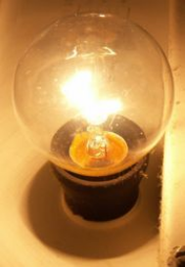

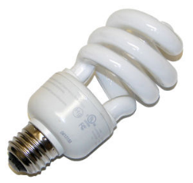

Incandescent light bulb Fluorescent light bulb

Please explain your answer.

5. Where does your body store energy for later use? Please choose the ONE answer that you think is best.

- Energy is stored in the form of matter.
- Energy is stored in the form of chemical energy.
- Energy is stored in the cell, but is separated from the matter of the cell.
- Energy is stored among the cells.
- The body does not store energy. Energy is produced when you need it.
- Other please list:_______________________________________________

Please explain why you think that the answer you chose is better than the others. (If you think some of the other answers are also partially correct, please explain those, too.)

6. A burning candle is put into an air-tight container. After some time, the candle stops burning.
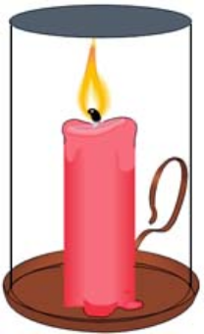

a) How does the air change while the candle is burning?

b) As the candle burns, it gets shorter in height. What happens to the matter in the wax after it melts and is burned? Please explain your answer.

c) Where does the energy for burning come from? Please explain your answer.
7. A tropical rainforest is an example of an ecosystem. Which of the following statements
about matter and energy in a tropical rainforest is the most accurate? Please choose ONE answer that you think is best.

a. Energy is recycled, but matter is not recycled.
b. Matter is recycled, but energy is not recycled.
c. Both matter and energy are recycled.
d. Neither matter nor energy is recycled.

Please explain why you think that the answer you chose is better than the others. (If you think that some of the other answers are partially right, please explain those, too.)

8. Carbon exists in different molecules or substances in nature. Please explain where carbon might exist in a forest. Complete the table below.

Question: | YES or NO | If YES, what substances or materials in these locations contain the carbon?
Do you think you would find carbon in trees?
Do you think you would find carbon in the soil?
Do you think you would find carbon in animals, like deer and wolves?
Do you think you would find carbon in bacteria in the soil?
Do you think you would find carbon in the air?
Where else might you find carbon?

